1. One stop complete packaging solution

Packaging cost reduction

1. Sustainable packaging

In transit damage reduction

1. Performance oriented warehousing solutions

Automation for high through put

1. Logistics possibilities & Cost effectiveness

Right time – right solution

**Our Services**

**Packaging**

**Delivering packages of excellence**

**Reduce operational cost**

**In transit damage reduction**

**Sustainable solutions – Reduce carbon footprint**

**Complete packaging solutions**

**€ Freight Saving € Unit cost reduction € Reduced product damage € Material optimization € Improved sustainability performance € Cost transparency € Packaging reuse € Pre-packaging € Innovative Design solutions € Testing – ISTA/UN**

**Warehousing**

**State of Art Approach**

*Warehouse is an intriguing concept. And one that has been debated about – or even attempted to be defined – since time immemorial. Not just scientists, but ancient philosophers like Aristotle, Plato and Socrates have dwelt upon what exactly is this thing called warehousing.*

**Warehouse Setup System Enhancement**

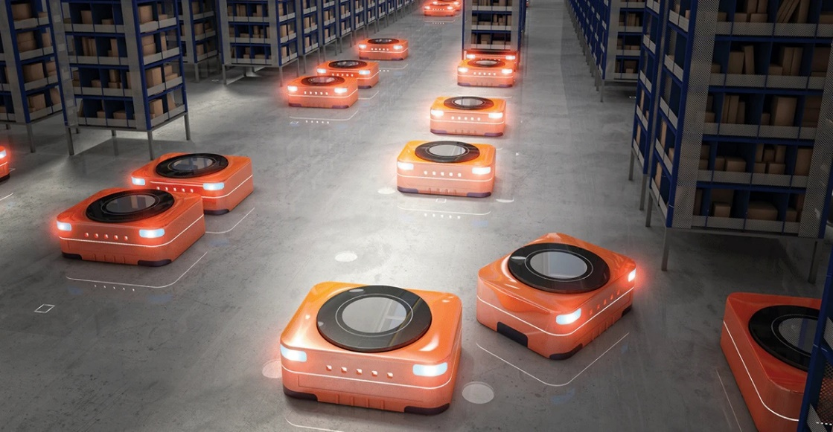

**Efficiency Enrichment**



**Financial Viability**

**€ End to End RFQ run € Location Finalization € Warehouse Design € Capex Finalization € ERP / WMS Implementation € Operational Automation € Process Improvement € Inventory Management € Team Management € Improving Cost Structure – Opex/Capex € Intangible cost reduction**

**Logistics Capabilities**

**Make the right move**

*Our logistics services can make your logistics hassle-free. We’ve got you covered – moving your cargo from warehouse to warehouse or door to door. We can provide tailor made logistics solutions which is best fit for your business.*

**Logistics Mode & Cost Reduction**

**Distribution Mode & Cost Reduction**

**€ Freight Saving € B2B Distribution € B2C Distribution € E-Commerce Distribution€ FTL / PTL Movements € Transit Damage reduction € Track & Trace € TMS – Transport Management System**